Thumbuddy Special’s

Winter Is Almost Over Party

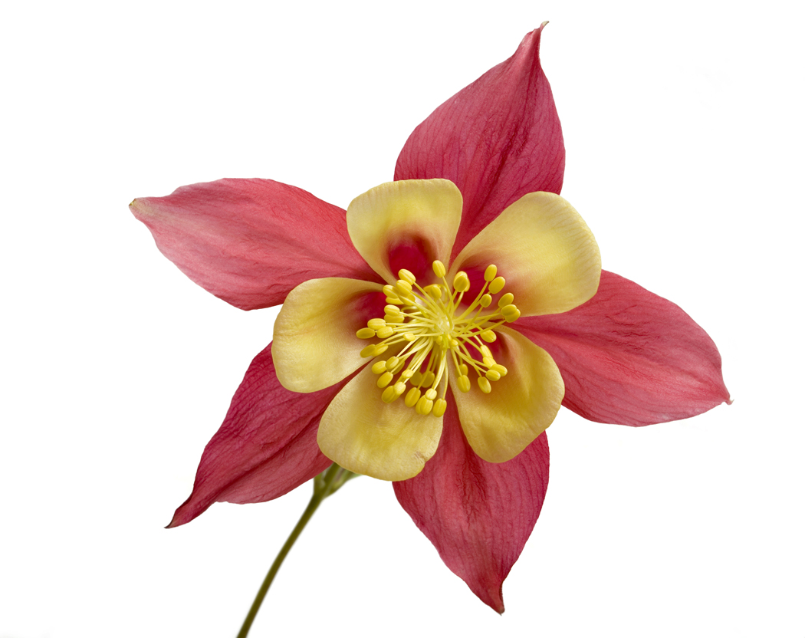
Saturday, March 5th, 2016
5 p.m. to 8 p.m.

Carlucci Restaurant
1801 Butterfield Rd Downers Grove

Come join us for a fun night out while supporting the children of Thumbuddy Special!


Cost: $55.00 in advance and $60.00 at the door.
*Includes beer, house wine, soft drinks and
Fabulous appetizers.

Live Band: The Joyce Boys Playing from 7:30-10:00 Dancing and desserts afterwards
Cash bar after 8:00

A limited amount of tickets will be available at the door so help us by
Responding in advance.

Return the registration below or email
Chris Gillis - mischris@wideopenwest.com

Yes, __________ will be attending the party.
(Number attending)
Name: _______________________ Amount enclosed: _______
________Sorry, can’t make it, but please accept this donation.
Thumbuddy Special P.O. Box 145 Downers Grove, IL 60515

